(Approx. 1,315 words)

Live CD-ROMs
By Dick Maybach, Member, Brookdale Computer Users’ Group, NJ
December 2013 issue, BUG Bytes
www.bcug.com
n2nd (at) att.net

A live CD-ROM contains all the files normally stored on a computer's hard disk and when booted acts exactly the same as a hard disk, except of course that it can't store data. Although these media are normally called “live CD-ROMs,” because they were available first, DVD-ROMs and USB memory sticks now can fulfill the same role. The hard disk plays no part when the PC boots from such a medium, and your PC will run fine even when its hard disk is malfunctioning or even absent. Moreover, the system leaves no traces on the PC of anything that occurred while it was running. However, the PC's hard disk is available as a storage medium, and, if it is operable, you can read from and write to it if you wish. Likewise, all the peripherals and ports are available; for example, you usually can access networks, including the Internet, use any USB devices, and do printing. There are several applications for live CD-ROMs:
- trial or installation of a new operating system,
- file system repair, backup, and restore, file recovery from corrupted hard disks, running diagnostics, disk cloning, and cleanup of malware, such as viruses and root kits,
- anonymous Internet browsing, and
- temporarily using other computers without risking making unwanted changes to them or leaving your passwords.

The overwhelming majority of portable operating system are based on Linux, as both Microsoft and Apple require a separate purchase for each computer, and transferring one of their operating systems among several computers violates their terms of service. There are a few based on DOS, but they are quite limited compared to their Linux counterparts.

Live CD-ROMs are most often available in the form of ISO images. These aren't files; instead they are bit-for-bit copies of the contents of a CD-ROM or DVD-ROM. Many media burners can write these; if yours can't, make an Internet search for “iso image burners” to find a suitable application. You may prefer to use a live memory stick which is faster, more convenient to carry, and can also store data. If so, I recommend the free program unetbootin, which converts an iso image to a suitable form and writes it to a stick. It's available for Linux, OS X, and Windows. Finally, if you have virtualization software, such as Oracle's VirtualBox, you can boot directly from the iso image file without burning anything.

To use a portable operating system, a computer must be configured so that it checks its CD-ROM drive and USB ports for bootable media before it checks the hard disk. Most computers check for CD- and DVD-ROMs, but you may have to set up your ROM BIOS to check for bootable USB memory sticks. Owners of new machines will also have to disable the safe boot feature on Macs and secure boot on PCs. Secure boot is a new “feature” of PCs that prevents software from running unless it has been approved by Microsoft. You should be able to disable it, but not all PCs allow this. It will make running live CDs more difficult, and may prevent them from running on some machines altogether. Finally, the use of live CDs on Macs can be problematic; you may have to do some reconfiguration or even replace your wireless keyboard and mouse, as these can have proprietary drivers.

Using a live CD-ROM to try out Linux on a Mac or PC is a common application, but a Windows installation disk is also an example, although it's limited to installing and repairing Windows. Regardless of what is on the hard disk, your computer will boot the live CD-ROM system; the hard disk has nothing to say about this. So long as you don't write to the hard disk, you can do whatever you like without affecting the installed system, which won't even know a session has taken place. CD- and DVD-ROMs and even memory sticks are much slower than hard disks, so don't expect speed. Aside from this, operation should be the same as though the system on the live CD-ROM were installed on your hard disk. If you have enough RAM, some light versions of Linux will transfer themselves to a RAM-disk, and these will be quite fast.

There are far too many portable operating systems to cover in this short article; see https://en.wikipedia.org/wiki/List_of_live_CDs for very brief descriptions of many of them. Instead, I'll introduce some examples that you can use as starting points for the applications listed above.

Trying out a new operating system

Which operating system you try out depends on the age of your hardware. (The critical feature that older computers lack is Physical Address Extension or PAE.) If your PC is modern enough to run Windows Vista or later, you should consider Ubuntu (840 Mbytes) or Linux Mint (960 Mbytes). (See the following two screen-shots.) Both have complete office suites and all the other applications you are used to, and both have full-service user interfaces with more bling available than you really need.

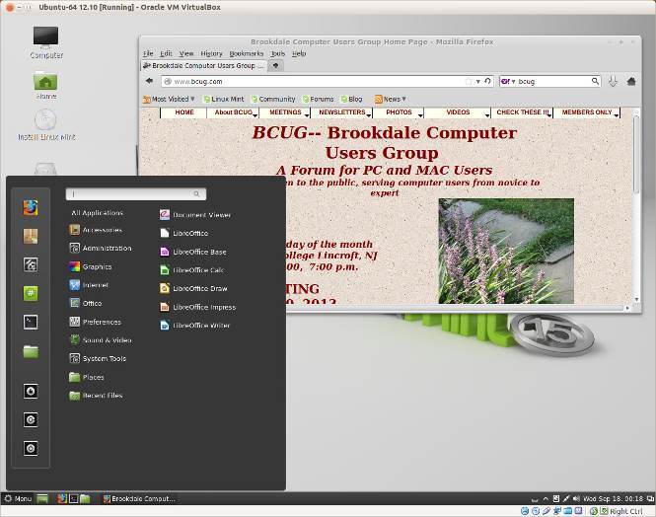

If your hardware dates from the XP era, it may lack PAE or a modern display controller and you'll have to be more careful. Something like Xubuntu (840 Mbytes) runs fine on older machines, but includes all the modern Linux applications found in the top-of-the line systems. However, its user interface is more Spartan.
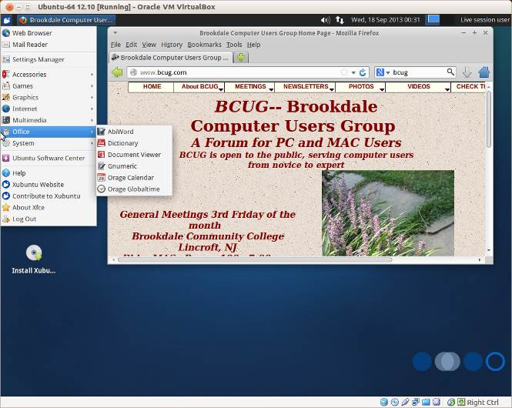

Diagnostic and Repair

For hardware and software maintenance and repair, I prefer Parted Magic (327 Mbytes), which I discussed in my April, June, July, and August 2012 articles, available at http://www.bcug.com. (See the screen-shot below.) The standard version of Parted Magic requires PAE; for computers without this, look the version with “586” in its iso filename. Unfortunately this valuable tool is no longer free, but its $5 cost is quite reasonable, and your can still find an older free version with a little searching. You may prefer SystemRescueCD, which also has a good reputation and is still free.
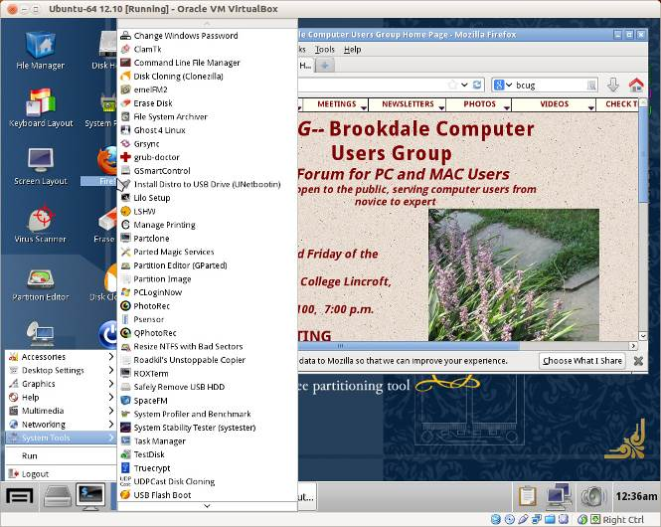
I haven't found DOS and Windows portable systems, such as Ultimate Boot CD or BartPE, to be effective. There are also some specialized tools, such as Network Security Toolkit and BackTrack, for penetration testing, i.e., computer and network hacking, but they require substantial expertise and are interesting only to network professionals.

Anonymous Browsing

For anonymous Internet browsing consider Tails (897 Mbytes). (See the screen-shot below.) You would use this for doing Internet banking from an insecure location, such as at a wireless hot spot or while using a borrowed computer. (It also provides added security when doing on-line banking from home.) It hides your IP address, encrypts all your communications, and leaves no traces (such as passwords) on the host computer. Because all its files are read-only, it can't be infected with malware, no matter how careless you are on line. If you operate Tails from a USB memory stick, you can create an encrypted directory on it to securely move files, so if you lose the stick, the finder can't access your data. It does not require PAE and so should run on almost any PC.
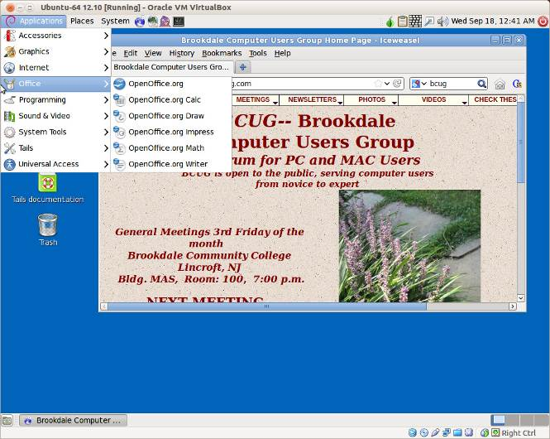

Portable Computing.

If you aren't concerned about security, but just want the convenience of having a familiar environment on a friend's computer, consider Puppy Linux (173 Mbytes). It provides only the basics, but probably everything you need. (See the screen-shot below.) Like Tails, if you use a live memory stick, you can create a partition on it to store your files, but they won't be encrypted, so don't lose the stick.
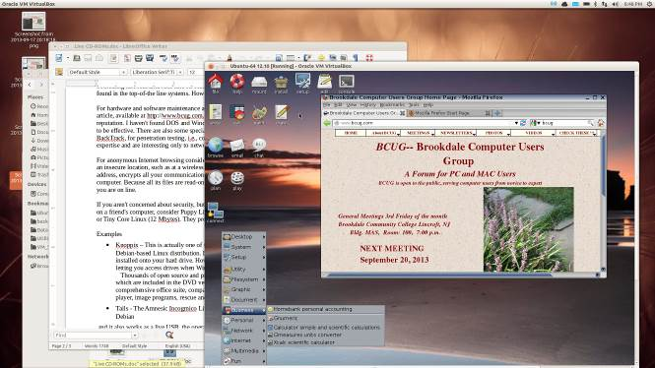

Damn Small Linux (52 Mbytes) and Tiny Core Linux (15 Mbytes) are even smaller, but of course they provide more modest capabilities.

I've introduced only a few of the hundreds of available live operating systems and suggested only a few uses. If none of them suit your needs, check the Internet.
Dick Maybach

